Enrolment Framework

1. Background & Context
Employee insurance enrollment ranges from simple base policies to complex flex configurations that allow multiple dimensions of customization (family definition, sum insured, plan selection, secondary plans, top-ups, and add-ons). Currently, complex enrolment—especially flex—is largely handled offline, followed by onboarding employees onto the final selected policies.
This PRD defines a unified enrolment framework that enables fully in-app enrolment for all supported policy constructs:
- Vanilla
- Modular
- Flex
This PRD focuses specifically on getting the framework right so enrolment journeys can be constructed based on what is allowed for an employee. Variables influencing eligibility and pricing (CD balance, minimum participation, grade/slab mapping) are handled in separate sections/tabs and are inputs to this framework.

2. Objective
Build a configuration-driven enrolment framework that:
- Renders enrolment journeys based on backend-configured allowed plan/component combinations.
- Enables employees to:
  - View current base coverage
  - Configure allowed upgrades/downgrades and add-ons
  - Add/edit/delete dependents within allowed constraints
  - Select secondary plans, top-ups, consolidated top-ups, add-ons
  - See dynamic premium impact and a final summary
- Tracks the employee’s enrolment state for correct communications and journey handling.
- Finalizes enrollment through a single submission that triggers backend processing and coverage activation.

3. Terminology & Policy Components
Component | Meaning | Who Usually Pays | Notes / Examples
Base Plan | Default plan assigned when employee joins | Mostly employer (sometimes partially employee) | Mandatory foundation
Secondary Plan | Additional plan with different family coverage | Employer / Employee (depends on setup) | Example: ESC + Parental plan
Top-ups | Extra coverage on top of base and/or secondary | Employer / Employee | Plan-specific or consolidated
Add-ons | Optional additional benefits | Mostly employee | Extra features beyond standard coverage; family definition can differ
Modular Top-ups | Upgrade base plan to higher tiers. Applicable only for modular plans | Employee (usually) | Often same family, higher coverage

4. Policy Types (Internal Classification)
Policy Type | What it Means | Plan Construct Includes | Key Differentiator
Vanilla | Straightforward setup | Base (mandatory), Secondary (optional), Top-ups, Add-ons | Choose extras on top of fixed base
Modular | Upgrade options | Base, Modular top-ups (alternate base plans/tiers), Add-ons. Secondary Plans and topups (rare) | Upgrade base by paying premium difference
Flex | Most customizable | Default base, alternate base plans (vary SI/family, or any sublimit/ cover within base plans), Secondary plans, Top-ups, Add-ons (flex module) | Curate coverage across family + SI + plan choice

5. Scope

In Scope of this PRD
- Framework for vanilla/modular/flex enrolment journeys
- Base plan handling (including upgrades/downgrades where applicable)
- Family member add/edit/delete
- Base plan top-ups
- Secondary plans (one or more) + their SI variants
- Secondary top-ups
- Consolidated top-ups
- Modular top-ups (tier upgrades)
- Add-ons (flex module) with potentially different family definition
- Package-level handling (multi-package enrolment)
- Summary page + dependent-wise coverage + payable summary
- Drop-off + resume
- Exception plans
- Partial employer/employee payment representation
- UHID strategy and implications

Out of Scope (covered in separate PRDs)
- CD balance logic and deduction mechanics
- Minimum participation logic
- Grade/slab mapping logic
- Deep PDP changes (except touchpoints for e-cards/wallet surfaces)
- Salary deduction schedule execution (one-time/monthly/quarterly): Will be picked up later (future scope).

6. Enrolment State Model (Required)
Each employee-package must be tracked in one of the following states (in case where in-app enrolment is enabled):
- NotStarted: employee has not initiated enrollment; no draft exists.
- InProgress: employee has entered enrollment and has draft inputs; coverage is not active.
- Completed: employee has submitted; backend processing triggered; coverage active or activating.

State Usage
- Drives communications (reminders, completion nudges, “coverage not active” warnings).
- Powers resume behaviour (continuation from saved draft).
- Controls what the employee sees on entry (start vs resume vs view-only).

7. Ideal employee Journey (Happy Flow)
- Backend pre-configures allowed policy/plan/component combinations per employee (per package).
- Employee starts enrolment → state becomes InProgress.
- Employee sees default base plan they are onboarded onto (this will be common for vanilla, modular, flex plans)
- Employee is presented with the allowed set of extra components based on policy type and entitlement:
  - base plan upgrade/downgrade (modular/flex)
  - top-ups
  - secondary plans
  - add-ons
- Employee configures selections and dependents; premium impact updates dynamically.
- Summary screen shows dependent-wise coverage and final employee payable.
  - This will be enhanced in later phases to incorporate monthly premium payment, quarterly premium payment variations.
- Employee submits enrolment → state becomes Completed.
- Backend executes finalization actions (plan creation/endorsement + UHIDs).

8. Base Plan Handling & Plan Change Endorsements

8.1 Base Plan Mapping (Mandatory)
- Every employee must be mapped to a default base plan.
- UI must clearly display the onboarded base plan. This involves:
  - Informing the employee details of the base plan.
  - Information about who is covered/ who is not covered.
  - A view on what is covered and what is not covered.
  - Followed by next steps for the employee to set context and process expectation:
    - A summary of base plan change (modular/ flex).
    - Coverage enhancement options. This is a broad term, but we want the employee to understand that they can enhance coverage for additional dependants or themselves.

8.2 Base Plan Change (Modular/Flex)
In case of modular and flex plans the employee can change their base plan altogether. Changing the base plan is treated as a plan change endorsement in backend terms.
Once the employee has been shown details of the base plan with the family definition, in next steps they should be able to first customize their base plan based on their preference.
Modular
- Show incremental premium for upgrade (premium difference).
- Clearly highlight the covered dependants in the base plans.
- Present tiers in a way that “pitches” the benefit/value clearly.
  - E.g. The silver/ gold/ platinum plans should be presented in a clear UI view so that employees can compare the benefits offered in each of the plans.
  - The view will be based upon the description of the components that have variants. E.g. If in base the OPD coverage is 10000, in silver it is 20000, and in gold the covered is 30000. Then the UI view would show a comparison across these plans (icons shown in the plan are for visual representation, we will make designs that are scalable).
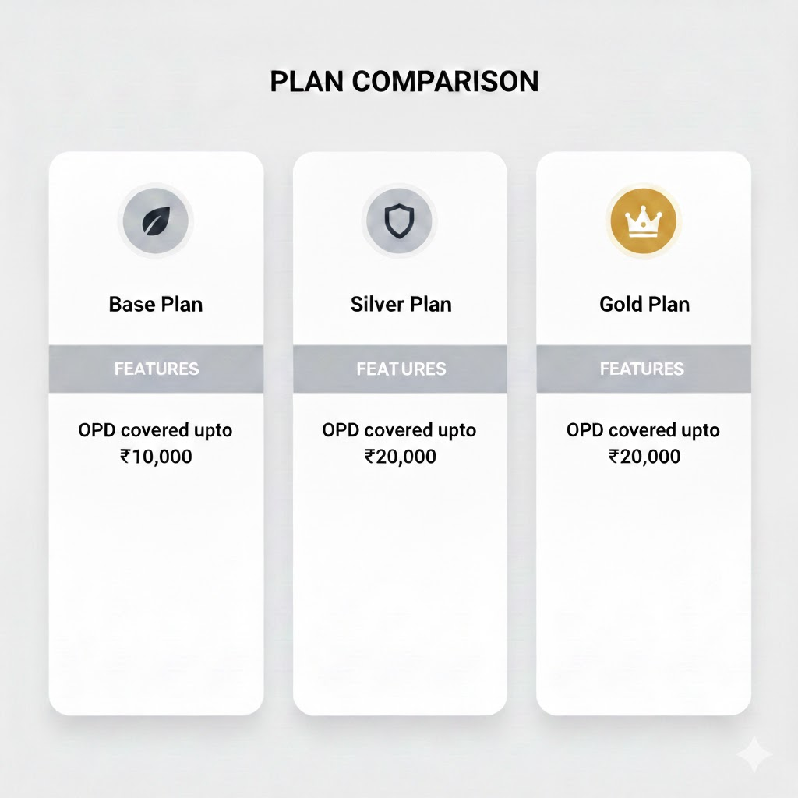
Flex
- Upgrade: If the employee upgrades the plan from their current base plan then the rater surplus has to be paid by the employee. We need to show premium to be deducted from salary/payroll.
- Downgrade: Likewise if the employee downgrades the plan, the difference in the rater of the base plan and the downgraded plan is the wallet balance available for consumption for buying other plans (wallet logic in separate PRD).

8.3 Variant Display for Base Plans
Base plans can vary via variants. How the variants will be shown on the UI is critical.
For modular
The base variants should be shown in a way that the employee is able to compare the plans clearly. The best option (design team will take a final call here) is a pricing comparison view for the plans.
The employee should be able to clearly understand the delta that each of these plans have in terms of coverage and the additional premium they will have to pay to upgrade to the plans.
For flex
Flex is a bit more complex than modular. Flex can have:
- Variants in components that are intuitive and can be easily explained to the employee.
- Variants in components that are not intuitive and are a bit complex to explain.
Treatment on UI for how each of the components’ variants is shown will be different. We need to figure out a way to capture this component level differentiation to be able to render UI correctly.
Explainable variants
- E.g. Sum insured
- Family definition
UI should allow selection/compare using direct controls (dropdowns/toggles/comparison).
Complex variants (not employee-intuitive)
UI must present these in a different treatment (comparison tables, info popovers, simplified benefit explanations), without expecting the employee to understand internal component semantics.

8.4 Combined Step Requirement
The base plan step must combine:
- base plan selection (for modular/flex)
- family member add/edit/delete for base plan

9. Family Member Management (Add/Edit/Delete)

9.1 Dynamic Dependent Eligibility
Allowed dependents must be shown dynamically based on the current selection (especially in flex). The UI must react instantly to plan changes (e.g., choosing a plan that allows parents to expose parents as an addable option). Only the allowed set of dependents should be visible as a selection for the employee to add.

9.2 Conditional Information (Incomplete Family vs Plan Family Definition)
If an employee selects a plan with a broader family definition (e.g., ESC) but adds only employee details, the UI must proactively inform them of the mismatch/implications.
A better way of doing this is how we have currently implemented this use case within our enrollment journey.

9.3 Mid-Year Family Expansion Scenario (Framework Capability)
Need clarity from bizops on this. This will be majorly covered from backend as per current understanding. The framework must be designed such that it can support future flows where an employee initially opts for a limited base (e.g., E) and later needs to upgrade the plan definition (e.g., add spouse/child due to marriage/baby). The specific endorsement execution and policy windowing rules may be handled later, but the framework must not block this capability structurally.

9.4 Secondary Plan Dependent Guidance from Base Screen
If secondary plans exist (e.g., parental policy), the base family screen should inform the employee that certain dependents can be added later as part of those secondary plans, and guide them to that step.

9.5 Backend-Driven Add/ Edit/ Delete Configuration (Forward-Compatible)
The frontend must be designed to reflect future backend-driven rules for which dependent operations are allowed (add/edit/delete) per plan and per dependent type, so that the framework scales with configuration changes. This will be implemented when we enhance PAT to configure dependent level add/ edit/ delete.

9.6 Edge cases/ Guardrails
This will be updated as and when we figure out cases that would need handling:
- Downgrade edge case handling (ESCP → ESC example)
If an employee selects a plan allowing parents, adds all dependents, then downgrades to a plan that does not allow parents:
- UI must clearly highlight the impact on the dependent(s) that become out-of-scope.
- Backend must handle dependent removal/flagging/coverage exclusion based on configured resolution behaviour.

10. Policy Component Handling

10.1 Base Plan Top-ups
- Allow selection of top-ups linked to base plan.
- Base top-ups share the same family definition as the base plan.
- Premium must update dynamically based on selection.
- Employees must be made aware of what the top-up is and who will be covered. This essentially would be the same family definition as that of the base plan.

10.2 Secondary Plans
Support one or more secondary plans (parental/child/sibling etc). For each secondary plan, the employee must clearly see:
- who the plan is for (eligible dependents)
- sum insured and core coverage configuration
- premium impact
Secondary plans must support both cases:
- Single Sum Insured (fixed SI, e.g., 5L parental plan)
- Multiple Sum Insured options as part of the secondary plan selection (e.g., 5L/10L/15L parental plan)
This is treated as configuring the base secondary plan variant (distinct from “secondary top-ups”).

10.3 Secondary Top-ups
Support top-ups scoped to selected secondary plans, similar to base plan top-ups but constrained by that secondary plan’s family definition and eligibility rules.

10.4 Consolidated Top-ups
Handle top-ups offered for a combined family definition across base and secondary plans. UI must aggregate and clearly communicate:
- total coverage impact
- premium impact
- who is covered across the consolidated definition. This is the summation of the base family coverage and the secondary plan family coverage.

10.5 Modular Top-ups (Tier Upgrades)
This has been discussed above. Highlighting the basic nuances here again. Specific to modular constructs:
- Present list of tiers clearly
- Emphasize benefits comparison and premium delta
- Selection replaces base plan tier configuration

10.6 Add-ons
Add ons can be offered in all of the policy types. The handling for each of the policy plans majorly remains the same.
- Allow employees to select from available add-ons.
- Premium impact should reflect employee payable (CD balance handling, minimum participation handling covered in other PRDs).
- Family definition for add-ons may differ from base plan; UI must capture and show this explicitly.
  - There will be cases when only E is covered in the add on selections, this should be handled.
  - There will be cases when the family coverage of the add on is same as the family coverage of the base, this should be handled.
  - There will be cases when the family coverage of the add on is custom. E.g. the base plan family definition can be ESCP, but the add on is offering ES coverage.
    - There is another variation here. The employee might be offered an explicit option of choosing the dependent for whom they’d want to purchase the add on. For the above example they can choose from either E or S or both. The premium will be shown accordingly.

10.7 Condition based plan rendering
Plan rendering logic must account for inter-plan dependencies, ensuring employees are only presented with eligible options.
Key Dependencies to Handle:
- Base Plan to Secondary/Add-on Plan Eligibility: The selection in the initial base plan step determines eligibility for subsequent secondary, top-up, or add-on plans.
  - Example: employees who select a base plan with a Sum Insured (SI) exceeding ₹7 Lakh should be eligible to opt for Outpatient Department (OPD) plans; otherwise, they should not.
- Add-on Plan to Add-on Plan Eligibility: Eligibility for a later add-on plan can be conditional on the employee's selection in an earlier add-on plan.
  - Example: If an employee selects an OPD add-on plan worth more than ₹30,000, they then become eligible to choose maternity-based add-ons.
Other cases like these should be handled as well.

11. Package-Level Handling
This is to be discussed with tech. Support enrolment journeys where a employee is onboarded onto multiple packages. The framework must:
- Maintain independent enrolment contexts per package
- Guide the employee through selection per package (sequential or grouped)
- Provide a consolidated final summary across packages

12. Summary Page and E-Cards

12.1 Summary Page Requirements
The summary must include:
- dependent-wise coverage details across base/secondary/top-ups/add-ons
- plan/component-wise configuration summary
- employee payable amount (if applicable)
- employer vs employee contribution split (this is in future scope when we implement the employer contribution functionality)
- deduction cadence placeholder (one-time/monthly/quarterly) (future scope)

12.2 E-cards / PDP Touchpoints
The phase is not expected to revamp PDP, except minimal integration needs for e-card related use cases and other tabs (wallet/min participation/CD surfaces).

13. Cognitive Design: Drop-offs, Resume, and Coverage Warning

Drop-off Handling
If the employee drops before submission:
- enrolment stays InProgress
- draft selections must be preserved
- the employee must be clearly informed that coverage is not active until submission

Resume Handling
Employees must be able to resume the journey from where they left off using saved state and draft data.

14. UHID Generation: Current State vs Proposed Approach

14.1 Current State
- After family details are submitted, UHIDs are generated for each dependent.
- UHID generation takes significant time and introduces latency.
- This latency contributes to funnel drop-offs during enrolment.

14.2 Proposed Approach
- Postpone UHID generation until final enrollment submission.
- During enrolment:
  - capture employee inputs (family + plan selections) as draft
  - use conditional rules passed to frontend (or configured in frontend) to render subsequent screens without requiring UHIDs
- On final submission:
  - generate UHIDs
  - create/endorse plans and finalize coverage

14.3 Pros
- Removes heavy latency from early steps.
- In cases where the employee goes through the enrolment journey multiple times, this approach will help simplifying the backend policy hits per employee, resulting in less DB entries.
- Improves completion rate by reducing mid-journey blockers.
- Allows smoother exploration of plan options.

14.4 Cons / Implications
- Some screens may be conditional based on employee selections; these must be rendered based on captured draft data and backend-provided conditions.
- If employee drops before submission:
  - UHIDs won’t exist
  - coverage will not be active
This must be communicated clearly and consistently.

15. Exception Plans
If the employee is onboarded onto exception plans:
- enrolment flow must not open
- The employee should directly see the e-cards.
To be discussed more with UW/ bizops.

16. Partial Employer / Employee Payment Handling (Framework-Level)
This will be covered in later phases. Highlighting the high-level requirement here for use case coverage.
Partial payments must be supported across base plans and other components.

Requirements
- For every selectable component (base, secondary, top-ups, add-ons, upgrades), the framework must support:
  - employer contribution
  - employee contribution
- UI must:
  - show the split clearly
  - reflect only employee contribution in the payable amount
- Dynamic recalculation must occur as selections change.
The mechanics of payment execution (CD, payroll schedule) are handled in separate sections, but representing the split correctly is required here.

17. Backend Configuration Expectations
Backend must provide per employee and per package:
- default base plan mapping
- allowed base plan alternates / tiers
- plan variants (SI/family definition) + display metadata for other variants
- dependent eligibility rules per plan
- add/edit/delete rules (forward-compatible)
- secondary plans available + their SI options
- top-ups (base, secondary, consolidated) with eligibility conditions
- add-ons with independent family definitions
- employer vs employee contribution splits
- premium outputs required for dynamic display and summary

18. Success Metrics
- Completion rate by policy type (vanilla/modular/flex)
- Drop-offs by step
- Average time to complete enrolment
- UHID-related latency reduction and funnel improvement
- Submission failure rate due to validation mismatches

CD Integration with Enrolment

1. Background & Context
In Group Medical Cover (GMC) policies, policy issuance is contingent upon premium payment. For corporate policies, this payment is handled through a Corporate Deposit (CD) account maintained by the employer with the insurer.

Currently, the employee app, which facilitates enrolment and policy selection, operates without real-time integration with the CD balance. This leads to policy issuance for employees based on selections, even when the required premium is not covered by the available CD balance. The mismatch is only discovered during subsequent reconciliation, leading to complex and negative user experiences, such as deboarding employees from policies.

This PRD outlines the requirements for integrating CD balance checks directly into the employee enrolment and policy issuance flow, ensuring that policies are only issued when the required premium is fully covered by the CD. This integration is critical for financial accounting accuracy and maintaining a positive employee experience.

2. Objective
To build an in-app framework that integrates Corporate Deposit (CD) balance checks with the employee enrolment and policy issuance workflow, ensuring:

- Financial Integrity: Policies are issued only if the CD balance is sufficient to cover the total required premium.
- User Experience: Employees are proactively informed of any delay in policy issuance due to CD unavailability.
- Employer Control: Employers are alerted about low CD balance and provided with tools to manage deposit top-ups and policy issuance for blocked employees.
- Operational Efficiency: Reduce post-issuance complications and deboarding due to premium shortfall.

3. Scope

In Scope of this PRD
Area | Requirement | Dev Requirements
Employee App | Integration of real-time CD check during/after enrolment submission. | - Realtime CD balance check before e-card generation.  - UI enhancement of the e-card views across PDP and web-app screen.  - Event trigger to highlight block due to CD unavailability.
 | Display of blocked status and clear communication on policy issuance delay.
 | E-card page revamp to communicate "issuance pending" status.
Backend/Core Logic | Configuration flag to enable/disable CD integration per partner/policy. | - Flag at partner level to enable CD based policy issuance.  - Realtime CD balance calculation.  - Intermittent status against employee selections to help track block due to CD.
 | Logic to block policy issuance when CD balance is insufficient.
 | Tracking of blocked employee policies and total outstanding premium.
Employer Portal | Email trigger to the employer when CD balance is insufficient for issuance. | - EP view/ section for showing insufficient CD.  - View to see blocked employees.  - Payment integration and suggested recharge amount calculation.
 | Dedicated view in the Employer Portal showing blocked employees and outstanding balance.
PAT or Replica of EP for Acko Ops | Functionality for Bizops/KAMs to manually approve policy issuance after payment confirmation. | - View within PAT/ a new portal for KAMs/ Bizops to retrigger the policy issuance once payment is made.  - View within PAT/ new portal for KAMs/ bizops to track partners where CD is insufficient and policy issuance is blocked.
Communication | Employee communication (email/in-app) on policy issuance status. | - Event trigger in case policy issuance is blocked due to CD.  - Event trigger when CD balance is added by the employer.  - Event trigger when KAMs/ Bizops trigger policy issuance (one for their trigger action and then individual events for the employees to enable communication)
 | Employer communication (email/portal) on balance shortfall.

Out of Scope of this PRD
Area | Requirement
CD balance top-up payment gateway integration | The actual financial transaction process for depositing CD.
Employer Portal redesign | Changes limited to the CD alert/management section.
Complete policy/e-card PDP revamp | Changes limited to communicating the "blocked" state.

4. Functional Flow: CD Integration
The following flowchart illustrates the proposed end-to-end flow from policy issuance to e-card generation, integrating the CD balance check.

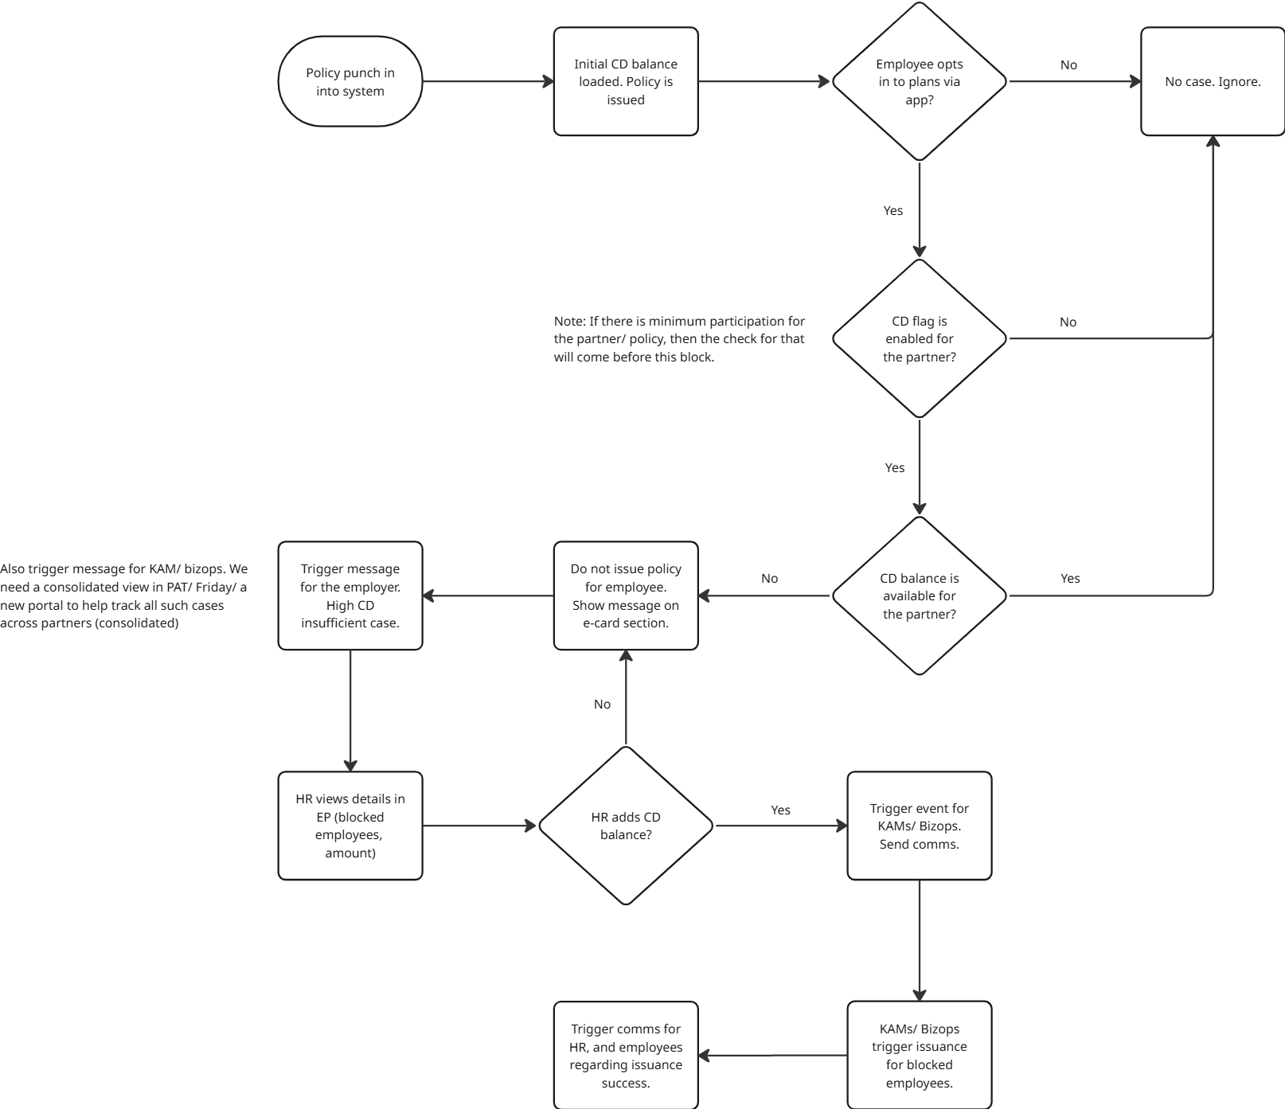

Step-by-Step Flow
- Initial Deposit: When the policy is initially issued, the employer deposits the Corporate Deposit (CD) with the insurer.
- Employee Action: An employee completes the enrolment journey or opts into an additional plan.
- System Check: Upon final employee submission, the system checks the available CD balance against the premium required for the employee's selections.
- Policy Issuance (CD Sufficient):
  - If CD balance is sufficient, policy issuance proceeds (after satisfying other criteria like minimum participation).
  - E-cards are generated, and the employee is communicated their active coverage (this communication needs to be built, owner: PM).
- Policy Block (CD Insufficient):
  - If CD balance is insufficient, the system blocks policy issuance for this employee/selection.
  - The employee is informed of the pending status.
  - The employer is automatically alerted.
  - Policy on E-card Generation for Multiple Plans with Insufficient CD Balance
    - It is crucial to note that if an employee selects multiple plans and their CD balance is insufficient to cover the total cost, no e-cards will be generated for any of the selected plans. This all-or-nothing approach ensures straightforward communication and simplifies the handling of plans.

5. Core Requirements

5.1 Backend Configuration
A mandatory configuration flag is required to control the application of this flow:

Field | Description | Type | Default
CD_Integration_Enabled | Enables the full CD check and blocking flow for a specific Partner/Policy. | Boolean | N (False)

Rule: If CD_Integration_Enabled is 'N', the system proceeds directly to policy issuance without checking the CD balance, reverting to the current behavior (subject to minimum participation and other checks).
This field should be built at the partner level configuration. There might be nuances around VAN availability, this needs to be discussed and added.

5.2 Employee App Experience (CD Blocked State)

5.2.1 E-Card Page Revamp
When an employee’s policy issuance is blocked due to insufficient CD balance, the e-card/coverage page must be revamped to reflect this:

- Clear Status: Display a prominent, non-alarming status indicating that Policy Issuance is Pending.
- Reason: Inform the employee that the policy will be issued once the final formalities (employer’s end) are completed.
- Base Coverage Access: Explicitly confirm that the employee still has access to the default Base Plan on which they were onboarded, mitigating immediate panic about coverage loss. This communication must be clear and reassuring.

5.3 Employer Portal Integration

5.3.1 Automated Alert
An email must be triggered to the employer's HR/Key Account contact when policy issuance is blocked for one or more employees due to CD unavailability.

5.3.2 Blocked Employees Dashboard
A new section in the Employer Portal is required, showing:

Metric | Requirement
Blocked Employees | Count of employees whose policies are pending issuance due to CD.
Total Outstanding Premium | The exact premium amount required to issue policies for all blocked employees.
Suggested Deposit Amount | A suggested amount to deposit: Outstanding Premium + buffer.
Suggested Deposit Options | Buttons/Options for the employer to easily select a deposit amount:
 | - Suggested Amount (100% of outstanding)
 | - 125% of Outstanding Premium
 | - 150% of Outstanding Premium
 | - Custom amount

Future Requirement: In the Employer Portal, enable the HR to select blocked employees and trigger a process to remove their policy selections, if the HR chooses not to pay and not to roll out the policy to those employees.

5.4 Bizops/KAM Action and Policy Issuance
A dedicated workflow is required for the Bizops/Key Account Manager (KAM) team:

- Verification: Bizops/KAMs verify that the employer's CD payment has been received.
- Manual Approval Trigger: The KAM/Bizops team must have an option in the Employer Portal to manually trigger the policy issuance for all blocked employees or a selected subset.
- Re-Issuance Logic: Upon trigger, the system must:
  - Re-check the CD balance (as a safeguard).
  - Execute policy issuance for the approved employees in FCFS manner.
  - Post-issuance, the employee receives the confirmation mailers, and the employee app reflects the active e-cards.

Decisions:
- Where will this portal sit? Who will do what? This will be picked up once we have discussion with Govind and KAMs on current SOPs.
- Based on the discussion a prototype of this feature will be shipped by product.

6. Data and Audit Requirements
- Tracking: The system must accurately track the individual premium required for each blocked employee's selection.
- Audit Trail: An audit trail must be maintained for the state transition of each policy (e.g., Blocked, Payment Verified, Issued).
- Important Events:
  - When policy issuance is blocked because of CD.
  - When CD balance is added/
  - When policy is issued after CD balance is added.

7. Success Metrics
Metric | Definition
Blocked-to-Issued Conversion Rate | Percentage of blocked policies that are successfully issued within 7 days.
CD-related Deboarding Reduction | Percentage reduction in the number of employees deboarded due to premium shortfall post-reconciliation.
Employer Alert-to-Top-up Time | Average time taken by the employer to top up the CD balance after receiving the email alert.
KAM/Bizops Issuance Success Rate | The percentage of issuance executions triggered by KAM/Bizops that succeed (i.e., CD balance is sufficient upon re-check).

Minimum Participation Handling

1. Background & Context
In Group Medical Cover (GMC) policies, employees are typically onboarded onto a default base plan. Employees are then offered the opportunity to select or opt-in to additional plans (e.g., higher Sum Insured, secondary covers, or add-ons) during an enrollment window.

To manage risk, hedge against negative selection, and ensure the commercial viability of certain plans, we require a Minimum Participation (MP) threshold to be met for these optional plans. If the requisite participation count or percentage is not achieved by the end of the enrollment window, the plan or policy may not be rolled out to the opting employees.

This PRD defines the framework and logic for integrating Minimum Participation requirements into the enrolment process, focusing on Phase 1 which involves data capture, employee communication, and manual decision-making by Key Account Managers (KAMs) and Bizops.

2. Objective
To implement a system and process that:

- Captures the Minimum Participation requirement at the plan/policy level in the backend.
- Allows employees to select MP-enabled plans while deferring policy issuance (e-card generation).
- Informs employees that their selection is pending final plan rollout.
- Enables the backend to track participation data for MP-enabled plans in real time.
- Supports a manual decision process for plan rollout post-enrolment, based on participation data.

3. Scope

3.1 In Scope (Phase 1)
Area | Requirement | Notes
Backend Configuration | Configuration flags to mark if a plan requires MP and its current rollout status. | Plan-level flags for MP_Required and Rollout_Status.
Employee App | Block e-card generation for MP-enabled plans until the Rollout_Status is updated. | E-card generation logic must check the Rollout_Status flag.
Employee Communication | Inform the employee immediately after selection that their response is recorded and policy issuance is pending the enrolment window closure. | Clear in-app messaging on the summary/e-card page.
Backend Data Capture | Capture and track the count of employees opting for each MP-enabled plan. | Real-time counting of unique employees selecting the plan.
KAM/Bizops Action | Functionality for KAMs/Bizops to download participation data during/after the enrolment window. | Manual process to support Phase 1 decision-making.
Rollout Decision Execution | Manual execution/logging of the rollout decision (Met, Not Met, Forced Rollout) by KAM/Bizops. | Rollout_Status flag update based on the KAM/ bizops manual action.
Post-Decision Employee Action | Send relevant communications and onboard employees onto final plans (rolled-out plan or alternate plan). | Requires a mechanism for Bizops/KAMs to assign employees to alternate plans if MP fails.
CD Balance Integration | Check CD balance required for all rolled-out plans and alert HR if insufficient (leveraging the CD framework). | CD check happens only after the MP rollout decision.

3.2 Out of Scope (Future Phases)
- HR view in Employer Portal for tracking participation and sending nudge emails.
- Automated movement of employees to alternate plans upon Not_Rolled_Out status.
- Handling of premium changes based on participation (UW/HR/KAM discussion).
- Detailed handling of MP by count vs. MP by percentage.

4. Functional Flow
The following placeholder represents the step-by-step flow of MP integration within the enrolment lifecycle.
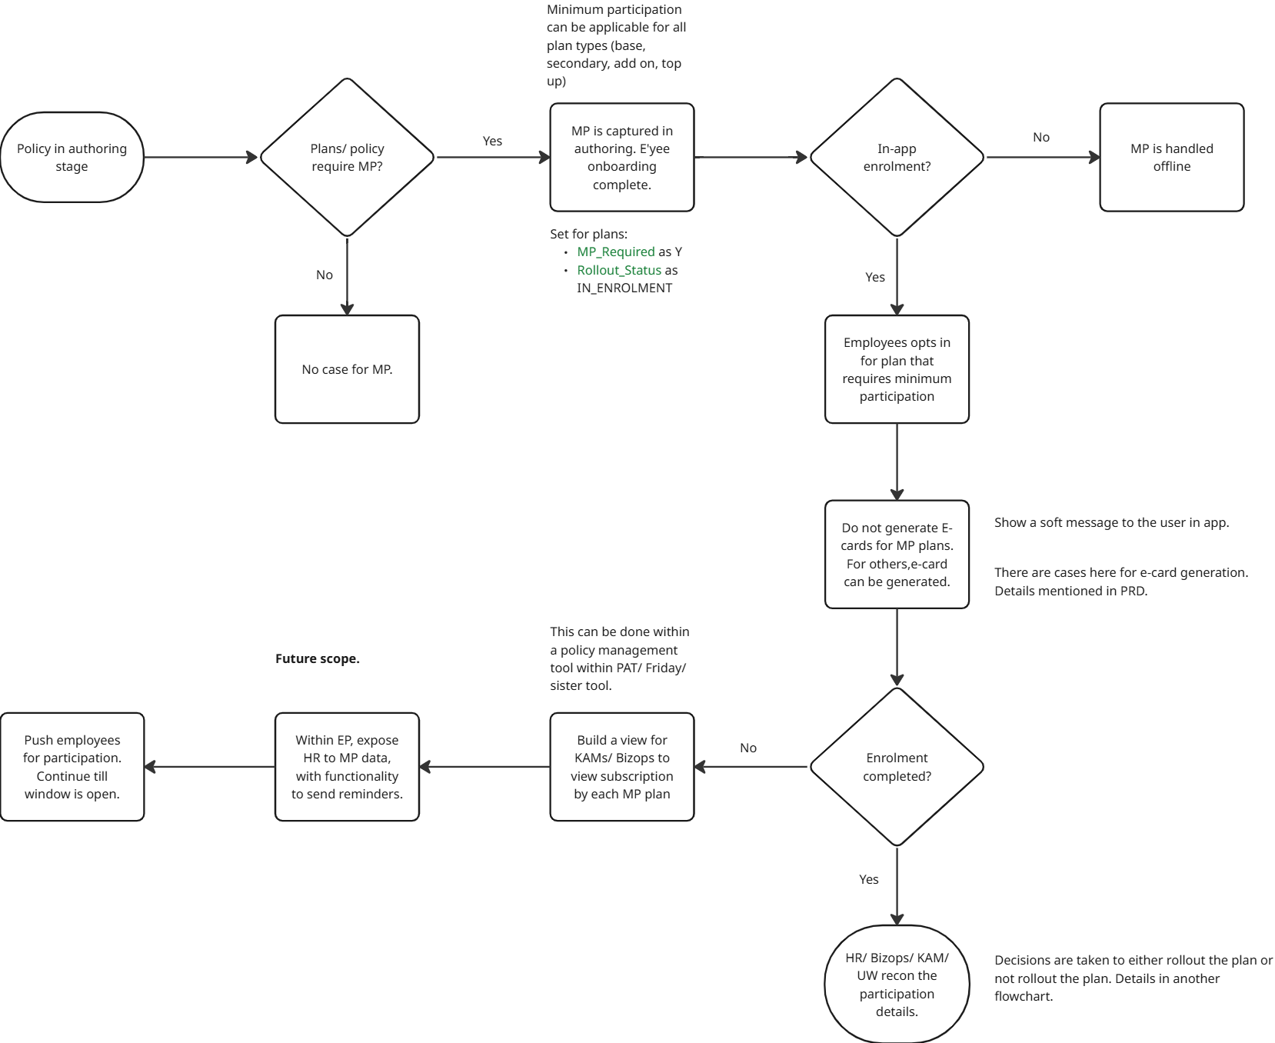
Post enrolment handling has been captured in flowchart in the subsequent sections.

5. Data Model & Flags
The following flags should be included in the plan/policy configuration to support front-end rendering and back-end completeness decisions, particularly for mapping the minimum participation requirement at the plan level:

Flag Name | Description | Type | Values | Default Status | Usage
MP_Required | Indicates if Minimum Participation is required for this plan/policy. | Boolean | Y/N | N | Controls MP flow and e-card blocking.
Rollout_Status | Tracks the current status of the plan's rollout decision. | String | IN_ENROLMENT, ROLLED_OUT, NOT_ROLLED_OUT | IN_ENROLMENT (if MP_Required=Y) | Determines if employees can be onboarded and e-cards generated.

Flag Logic:

- If MP_Required = Y, then Rollout_Status defaults to IN_ENROLMENT.
- E-card generation for the specific plan is only allowed if Rollout_Status = ROLLED_OUT.
- Once the enrolment window closes, KAM/Bizops update Rollout_Status to either ROLLED_OUT or NOT_ROLLED_OUT

Rollout Decision Guardrails for Minimum Participation (MP) Plans
To ensure a final rollout is only triggered after a decision has been made for all plans requiring minimum participation, two main guardrails will be implemented:
- MP Decision Logged Flag: A new flag, MP_Decision_Logged (default value 'N'), will be added to plans requiring MP. The rollout will only proceed if this flag is set to 'Y'. The specific logic for setting this flag will be detailed in a separate section.
- Rollout Status Check: For all plans where MP_Required is 'Y', the Rollout_Status flag must be checked. Its value must be either ROLLED_OUT or NOT_ROLLED_OUT.

6. Employee Experience (In-App)

6.1 During Enrolment
When an employee selects a plan where MP_Required = Y:

- The premium is dynamically calculated and shown (if applicable), but the payable amount is not deducted.
- The final summary page or e-card view must contain a clear, prominent message (this message is just a sample, exact design and copy will be updated later):

Important Notice: Policy Issuance Pending
Your selection for this plan has been successfully recorded. Policy issuance and e-card generation for this specific plan are pending the closure of the company's enrolment window and successful fulfillment of the Minimum Participation requirement. We will update you once the final decision is made.

6.2 After Final Decision
After the final decision on the plan rollout has been made, the employee will receive relevant communication based on their selection and the rollout decision.
Final Status of the plan | Employee Action/Experience
ROLLED_OUT | Employee receives communication. E-card/coverage details are now active and visible in the app. UHID is generated.  Cases:  - Employee onboarded on to plan of their choice.  - Employee onboarded on to an alternate plan.
NOT_ROLLED_OUT | Employee receives communication informing them the plan will not be rolled out. The employee is moved to an alternate active plan (determined by Bizops/KAM) or the default base plan. The selection is removed from their active coverage view.

7. Rollout Decision and Execution
This phase relies on manual data exchange and decision-logging. Here is the flowchart of the workflow from enrolment window closure to the plan rollout to the employee. Details for each of the components have been highlighted in the subsequent sections/ sub-sections.
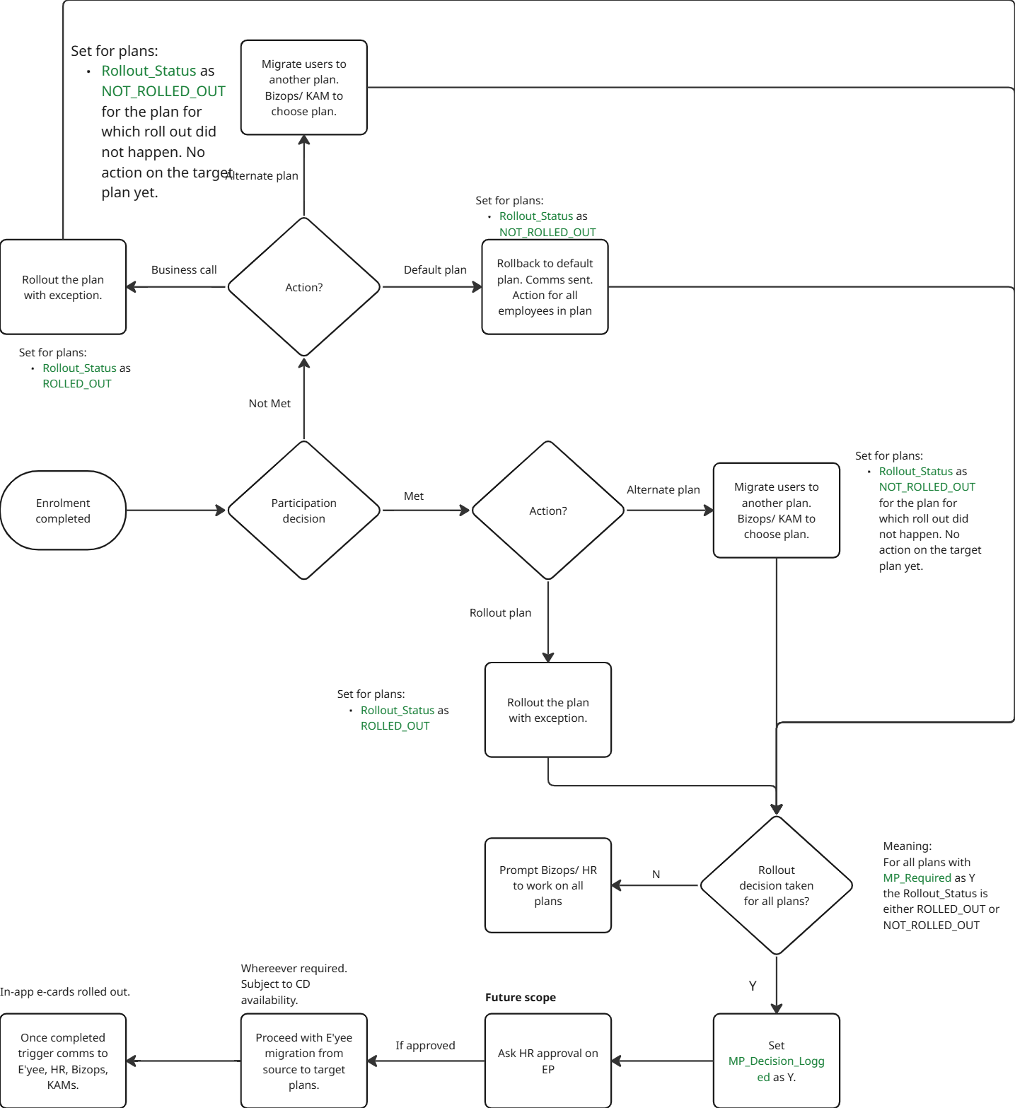

7.1 Data Extraction
KAMs/Bizops must be able to download the following data during or after the enrolment window:

- Plan Name (where MP_Required=Y)
- MP Requirement (if applicable and available, target count/%)
- Current Participation Count
- List of employees who opted for the plan and also those who had not opted (for targeted follow-up).

7.2 Post-Enrolment Completion Process
Proto for this feature will be updated by Product.
- Recon: KAM/Bizops sit with the HR to reconcile participation data and determine the final rollout decision.
- Decision Cases: The final decision results in one of three outcomes:
  - Requirements Met: In this scenario, two options exist for rolling out the plans:
    - Option 1: Rollout Selected Plan
Employees are onboarded onto the plan of their choice.
    - Option 2: Rollout Alternate Plan
Employees are onboarded onto a plan different from their selection (and their default plan). This may occur if HR decides to roll out certain plans despite not meeting participation requirements.
Action for KAM/BizOps: A view should be available allowing KAM/BizOps to either rollout the selected plan or change the plan and then rollout the new selection.
  - Requirements Not Met: When participation requirements are not met, there are two primary options:
- Option 1: Rollback to Default Plan
  - Employees are automatically reverted to their default plan.
- Option 2: Move to Alternate Plan
  - Employees are moved to a plan other than their default plan. This can happen if HR chooses to roll out an alternate plan, even if it also did not meet participation requirements.
Action for KAM/BizOps: A view should be available enabling KAM/BizOps to either rollback employees to the default plan or change the plan and then rollout that new selection.
- Requirements Not Met, but Plan is Rolled Out: In a scenario where requirements are not met, but a business decision is made to proceed with the rollout:
  - Action for KAM/BizOps: A specific option must be provided for KAM/BizOps to rollout the plan while also adding mandatory comments explaining the decision.
Overall Goal: All plan rollout operations must be easy and seamless for the employees.

7.3 Finalization and Cleanup
The participation closure request can be submitted by Bizops/KAMs only after a Rollout_Status has been finalized (either 'ROLLED_OUT' or 'NOT_ROLLED_OUT') for all plans marked with MP_Required=Y. This strict requirement ensures that all potential edge cases related to impartial or premature rollouts by HR/KAM/Bizops are covered.
Post-Submission Process:
- CD Balance Check: If the partner has enabled the CD balance mapping flag, a CD balance requirement is created.
- Configuration Update & Employee Movement: If the CD is sufficient, the new plan configurations are saved, and employees are moved from their source plans to the target plans as necessary.
- Status Update: The value of MP_Decision_Logged is set to ‘Y’. Note: The order in which this flag’s value is to be set to ‘Y’ needs to be discussed.
- Employee Onboarding: UHIDs are generated, and in-app e-cards become visible to employees.
- Final Communication: Final communication is sent to the employee, HR, broker, KAMs, and Bizops.
Important Note: Once MP_Decision_Logged is set to ‘Y’, employees onboarded subsequently will no longer see plans with a Rollout_Status of ‘NOT_ROLLED_OUT’. Minimum participation requests are therefore irrelevant for these newly onboarded employees.

8. Handling of MP Levels
The MP requirement can be applied at different levels:

- Individual Plan Level: MP applies only to a specific plan. Other eligible plans are rolled out normally, but the MP-enabled plan is blocked until the decision is made.
- Group of Plans Level: A set of plans share a combined MP requirement (aggregate or individual + aggregate). Plans without MP are rolled out. MP-enabled plans are blocked together.
- Policy Level: MP applies to the entire policy. No e-cards are generated for any plan under the policy until the MP decision is finalized.

9. Success Metrics
- Decision Time: Average time taken from the end of the enrollment window to the logging of the MP_Decision_Logged flag.
- Manual Intervention Rate: Number of times KAMs/Bizops manually assign employees to alternate plans.
- Enrolment completion to policy rollout TAT: This should reduce from the existing manual process.

Grade Based Handling

1. Background & Context
Group Medical Cover (GMC) policies are often structured with differentiated benefits based on an employee's organizational standing, commonly defined by factors such as:

- Designation
- Compensation (CTC)
- Experience level
- A combination of the above (referred to as Grades/Slabs).

HR teams require the ability to roll out distinct sets of insurance plans and options tailored to these specific employee grades. The current challenge is to ensure that the enrolment journey presented to an employee is strictly limited to the plans and configurations relevant to their assigned grade, enabling complex policy administration and selective benefit rollout.

This Product Requirements Document (PRD) defines the framework required to map plans to specific grades in the backend (Policy Authoring Tool - PAT) and use this mapping to run grade-aware, relevant enrolment journeys on the frontend.

2. Objective
To implement a robust, configuration-driven framework that enables grade-level segregation of policy benefits, ensuring:

- Backend Configuration: The Policy Authoring Tool (PAT) can capture grade names and map individual plans and components to one or more specific grades.
- Endorsement Coherence: Employees are systematically onboarded to the correct default plan corresponding to their assigned grade during the endorsement process.
- Frontend Relevancy: The employee enrolment journey only displays the plans, top-ups, secondary plans, and add-ons that are explicitly mapped to their grade.
- Operational Flexibility: The system supports the creation of internal, operational grades (even if not formally provided by HR) for selective benefit rollout (e.g., higher OPD for VP+).

3. Scope

In Scope
- Design and validation rules for grade-level mapping in PAT.
- Logic for mapping employees to their respective grades.
- Logic for onboarding employees to the default plan of their grade during endorsement.
- Logic for filtering the frontend enrolment options (plans, top-ups, add-ons) based on the employee's assigned grade.
- Handling of grade-related endorsement changes (e.g., an employee moves to a new grade).
- Handling multiple plans of the same type within a single grade, including the concept of a default plan.

Out of Scope (Assumed Standard Framework)
- Corporate Deposit (CD) balance checks.
- Minimum Participation (MP) requirement checks.
- Integration with external HRMS systems for automated grade updates (Future Scope: Rule-based grades).
- EP integration to enable HR to build grade logic and run endorsements based on the employee grade/ slabs. This might have to be built in the current scope to support EP endorsements.

4. Backend Requirements (Policy Authoring Tool - PAT)
The Policy Authoring Tool (PAT) must be enhanced to capture and validate grade-level data:

4.1 Grade Capture and Mapping
- Grade Name Definition: PAT must allow Bizops to define a list of grade names applicable to the policy (e.g., "Analyst," "Manager," "VP+"). These names will be shared across all plan types within the policy.
- Plan-to-Grade Mapping: Every plan created within PAT must include a mandatory field allowing it to be mapped to one predefined grades.

4.2 Validation Rules in PAT
To ensure data coherence and operational stability, the following validations must be enforced at the PAT level:

Validation Rule | Description | Rationale
Mandatory Grade Mapping | If the policy has defined grades, every plan created must be mapped to one grade. | Prevents unmapped plans from causing errors or being inappropriately rolled out.
Default Plan per Plan Type/Grade | If a grade has multiple plans of the same plan type (e.g., two different Base Plans), one must be explicitly marked as the Default Plan for that grade.  If there is only plan per plan type per grade then that plan should be set as default plan (either manually or automatically, needs to be decided) | Crucial for the endorsement process, ensuring every employee is onboarded to a known, anchor plan for their grade.
Unique Default Plan | A grade can only have one default plan for any given plan type. | Maintains coherency during automated endorsement and avoids ambiguity.

4.3 Plan Duplication Strategy (Multiple Grades)
Decision: The current implementation supports the creation of multiple plans (one for each grade) to accommodate variations in premium, Sum Insured (SI), or other plan configurations by grade.

- Requirement: If the same plan is applicable to all grades within a policy, individual plans must be created for each grade.
  - For instance, if a plan configuration, "Plan A," is intended for grades G1, G2, and G3, then three separate clones of Plan A will be generated, each mapped to a single grade (one for G1, one for G2, and one for G3).
- Rationale: Creating individual plans explicitly handles complexity like differential premium rates (e.g., age-based premium that varies by grade/slab). This approach, while resulting in more plan entries, provides maximum flexibility and leverages existing rater logic.
This is to be aligned with bizops and tech.

5. Employee Enrolment Workflow

5.1 Endorsement (Onboarding) Logic
During the policy endorsement run, the following must occur:

- Employee-to-Grade Mapping: Each employee must be mapped to a specific grade. This mapping can be driven by a data upload or, in the future, integration with HRMS.
- Default Plan Onboarding: Employees must be onboarded onto the plan explicitly marked as the Default Plan for their assigned grade.

5.2 Frontend Enrolment Journey
Once the employee starts the in-app enrolment journey, the frontend logic must strictly adhere to the following filtering rules:

- Identify Employee Grade: The system must retrieve the employee's assigned grade.
- Filter Base Plan Options: The base plan displayed as "current" and any alternate base plans available for upgrade/downgrade (in Modular/Flex) must be filtered to show only those mapped to the employee's grade.
- Filter Components: All available options—Secondary Plans, Top-ups (Base, Secondary, Consolidated), and Add-ons—must be filtered to show only those components mapped to the employee's grade.

User Grade | Enrolment Options Displayed
Grade A | Default Base Plan (Grade A), Modular Top-ups (Grade A), Add-ons (Grade A)
Grade B | Default Base Plan (Grade B), Alternate Base Plans (Grade B), Secondary Plans (Grade B)

5.3 Handling Edge Cases and Fallbacks
Scenario | Issue | Required System Action
Employee on Wrong Grade | Employees are onboarded onto the default plan of Grade A, but their true grade is Grade B. | Immediate Solution: Bizops must manually trigger a plan change endorsement for the affected employee to move them to the correct Grade B default plan.
New Plan Addition | HR/Bizops wants to roll out a new Add-on/Top-up for a specific grade after the initial setup. | Action: Bizops must create the new plan in PAT and map it to the target grade(s). The next time the employee in that grade begins or resumes enrolment, the new option will appear.
Internal grades required by Bizops | HR does not formally provide grade information (e.g., a small company), but Acko requires internal segregation for selective benefits (e.g., higher benefits for senior roles). | Action: Bizops must create internal, operational grades (e.g., "Ops Grade 1," "Ops Grade 2") in PAT, manually map the relevant employees to these grades during the initial endorsement, and configure plans against these internal grades.
Employee Not Mapped to Any Grade | During endorsement, an employee cannot be matched to any defined grade. | Action: System must flag this as an Endorsement Error. These employees cannot proceed with enrolment until a valid grade is assigned.

6. Success Metrics
- Grade Mapping Integrity: Zero validation failures in PAT for grade-level rules (e.g., no unmapped plans when grades are defined).
- Endorsement Accuracy: 100% of endorsed employees are correctly mapped to their grade's default plan.
- Enrolment Relevancy: Zero support tickets related to employees seeing irrelevant plans or missing eligible plans due to grade mismatch.
- Operational Efficiency: Time saved in manual operations (e.g., custom plan configuration per employee) due to grade-level segregation.

7. Future Scope
- Rule-Based Grades: Implementing a system where grades are not manually assigned but determined dynamically at the time of endorsement based on employee data (e.g., IF Designation = 'VP' OR CTC > 'X' THEN Grade = 'VP+'). This requires integration with HRMS or dynamic data ingestion.
- Plan Simplification: Exploring technical solutions to optimize plan creation, potentially allowing a single plan entity to hold multiple grade-specific configurations (e.g., different SI values or premium rules per grade) without requiring full plan duplication.

Flex Wallet Handling

1. Background & Context
In flexible (Flex) insurance policies, employees are typically onboarded onto a default base plan, the premium for which is primarily borne by the employer. This employer-paid premium for the default plan effectively functions as a pre-purchased 'Wallet Balance' for the employee, which they can use to configure or upgrade their coverage.

When an employee makes a change (downgrade/upgrade their base plan) or opts into additional components (secondary plans, top-ups, add-ons), the system must manage the financial adjustments relative to this Wallet Balance. This adjustment can result in:

- Unused Balance: A surplus in the Wallet that must be accounted for (refunded to the Corporate Deposit (CD) account).
- Employee Payable: A deficit that the employee must cover (via payroll deduction, which is initially debited from CD and recovered by HR).

This PRD focuses on establishing the framework for managing these wallet-related financial transactions within the Flex enrolment flow.

1.1 Scope of this PRD (Phase 1)
This PRD focuses on the two primary Wallet configuration use cases:

- Wallet = Default Plan Premium: The Wallet Balance is exactly equal to the premium of the default base plan.
- Wallet > Default Plan Premium: The Wallet Balance is greater than the default plan premium, where the HR provides an additional custom amount for the employee to spend.

Use Case 3 (Custom Wallet, Unlinked to Base Plan) will be covered in a future phase.

1.2 Not in scope of this PRD
- What would happen in cases where there is an employer contribution less than 100% (partial payment by the employer)?

2. Objective
To implement a robust, auditable framework that integrates the Wallet Balance concept into the Flex enrolment flow, ensuring accurate representation, consumption, and reconciliation of funds by:

- Dynamically calculating the premium consumed by employee selections.
- Clearly communicating the Wallet Balance status (consumed, unused, payable) to the employee on the frontend.
- Handling the backend transactions (debit/credit) with the Corporate Deposit (CD) account based on the final selections.
- Ensuring forward compatibility with future payroll deduction and exception flows (CD and Minimum Participation).

3. Functional Requirements

3.1 Wallet Balance Definition
Component | Definition | Scope of this PRD
Wallet Balance | The total premium amount sponsored by the employer for the employee's plan configurations. | Wallet = Default Plan Premium OR Wallet = Default Plan Premium + Custom Amount (via Bizops configuration).
Consumed Premium | The total premium of the employee's final selected configuration (Base + Secondary + Top-ups + Add-ons). | Calculated dynamically throughout the enrolment journey.
Unused Balance | Wallet Balance - Consumed Premium (if positive). | Refunded to CD at final submission.
Employee Payable | Consumed Premium - Wallet Balance (if positive). | Debited from CD initially, to be recovered by HR via payroll.

3.2 Wallet Configuration and Definition
The Wallet Balance must be tracked at the employee level for each enrolment package.

3.2.1 BizOps Capability
A capability must be built for Bizops/Admin to define the Wallet Balance:

Requirement | Implementation Detail
Wallet Visibility | Bizops must be able to view the default plan premium for the onboarded plan, which will be the default Wallet Balance.
Custom Amount Configuration | Bizops must have a screen/tool to configure a custom amount (which must be >= 0). This amount will be added to the default plan premium to form the total Wallet Balance. Where should this be placed? Need discussion here.
Configuration Level | Ideally, the custom amount configuration should be captured at the default plan level during plan configuration. But this not scalable assuming that there might be changes later. (To be discussed and aligned with Tech team.)
Wallet Update Handling | The system must handle updates to the Wallet Balance amount even after an enrolment or endorsement has been run. The transaction tracking (Section 3.6) must use the latest amount as the baseline.
EP Integration | The wallet configuration should be integrated with the Employer Portal (EP) so HR/Admin can view the sponsored amount.

3.3 Wallet Consumption Use Cases and Frontend Handling
The frontend (Employee App) must clearly communicate the financial implication of the user's choices based on Wallet consumption.

Use Case | Consumed Premium vs. Wallet | Frontend Display & Action
Consumption = 100% | Consumed Premium = Wallet Balance. | Summary: Wallet Amount X, Consumed Amount X. Action: No action required. As the required CD amount would have already been debited.
Unused Balance | Consumed Premium < Wallet Balance (Unused Balance = X - Y). | Summary: "You have consumed Y out of your X Wallet Balance. You have X-Y remaining." Recommendation: Strongly encourage the user to utilize the remaining balance for coverage enhancements (e.g., top-ups, add-ons). Critical: Inform the user that the unused amount will not be refunded to their personal account.
Employee Payable | Consumed Premium > Wallet Balance (Payable = Y - X). | Summary: "Your total selection premium is Y. Your employer-sponsored Wallet is X. You need to pay X amount." Action: State that the X amount will be deducted from their salary (via payroll).

3.4 Backend Transaction Handling (CD Debit/Credit)
The final CD transaction (Debit/Credit) is triggered only upon the employee's final submission of the enrolment journey, ensuring the InProgress state is completed.

Scenario | CD Transaction Logic | Dependency
Unused Balance | Refund the Unused Balance back to the Partner's Corporate Deposit (CD) account. | Requires alignment with Finance/BizOps on exact CD credit operations.
Employee Payable | Debit the Employee Payable amount from the Partner's Corporate Deposit (CD) account. HR will recover this amount from the employee via payroll deduction. | Debit will be a blanket deduction now (monthly/quarterly options are Future Scope).
No Change | No CD transaction required (amount is implicitly consumed and accounted for). | N/A

3.5 Handling of Multiple Enrolment Attempts (Drop-off & Resume)
An employee can enter, exit, and resume the enrolment journey multiple times before final submission.

Requirement | Implementation Detail
State Tracking | The employee's Wallet Balance and current consumed premium must be tracked at each InProgress state save (Draft data).
CD Transaction Rule | CD credit/debit actions must only be performed upon final submission. Previous draft state transactions are discarded.
Scenario Example | Attempt 1 (Enrolment completed): Employee has Unused Balance. CD should be credited by the unused amount. Attempt 2 (Enrolment completed again, more selections made): Employee consumes more, resulting in Employee Payable. CD is debited for the payable amount.
Principle | We should allow multiple debit/ credits from CD per employee based on the multiple enrolment journey selections based by them. Final recon should be done based on the wallet amount sponsored for them.

3.6 Wallet Consumption Audit Trail
All transactions related to Wallet consumption must be logged:

- Transaction Tracking: Track the consumption of the Wallet Balance against each component selected (Base Plan, Secondary Plan, Top-ups, Add-ons).
- Employee Recon: Once the enrolment window closes, a final reconciliation report must be generated for each employee, summarizing:
  - Initial Wallet Balance
  - Final Consumed Premium
  - Net CD Credit/Debit
- HR Report: This net summary should be made available to HR via the Employer Portal for their internal payroll recovery and accounting.

4. External Dependencies and Nuances

4.1 Corporate Deposit (CD) Integration
This flow would work best on the Partner/Policy having the CD Integration Enabled (as defined in the CD PRD).

- CD Balance Check: If the Partner's overall CD balance is insufficient, the post-summary flow defined in the CD PRD kicks in, blocking e-card generation until the CD is topped up.
- CD Operations Alignment: A mandatory alignment meeting with Finance and BizOps is required to confirm the technical implementation of CD credit and debit operations (e.g., API endpoints, accounting codes) to support the two-way flow (debit for payable, credit for unused).

4.2 Minimum Participation (MP) Integration
If a plan selected by the employee is subject to Minimum Participation (MP), the CD debit/credit action is temporarily conditional.

MP Scenario | Wallet Action
Base Plan & Non-MP Plans | Wallet consumption and CD debit/credit runs normally for selections not subject to MP.
MP-Enabled Plan Selection | The full premium for the MP-enabled plan is factored into the Consumed Premium calculation (affecting Employee Payable/Unused Balance). However, the final CD debit/credit related to the MP-enabled plan should be contingent upon the plan being ROLLED_OUT (as defined in the MP PRD).
MP Failure | If the MP-enabled plan is NOT_ROLLED_OUT, the premium associated with that selection must be credited back to the CD, and the employee's Consumed Premium must be recalculated based on their final active plans.

4.3 E-Card Generation Delay
In any case where e-card generation is delayed (e.g., due to CD shortfall or MP status), the CD debit/credit transaction must also be delayed or reversed if the enrolment is invalidated, ensuring financial accuracy.

5. Success Metrics
Metric | Definition
Wallet Consumption Rate | Percentage of Wallet Balance used by employees in Flex policies.
Refund Accuracy | Audit success rate for the reconciliation of unused balance (credit to CD).
Payable Accuracy | Audit success rate for the reconciliation of employee payable amounts (debit from CD).
EP Reconciliation Adoption | Percentage of HR teams using the Wallet Recon report in the Employer Portal.

Events and Configurator.
Note for events: The specific list of events, the detailed alert content, and the design/placement within the user journey will be picked up and finalized once the UX/UI designs for the enrolment flow are available.

Note for configurator: This will involve enabling flex and modular policy configuration on the configurator. Same as above, it will be picked up once we finalize the UI designs. This might be an ambitious stretch for phase 1.

Open questions and discussions
Below is a list (active) of topics that need discussion:

S. no. | Topic | Document link | To-be discussed with | Status | Outcome
1 | Inter-package enrolment handling: | PRD: Enrolment Journey Revamp Phase 1
2 | Enrolment for exception plans | PRD: Enrolment Journey Revamp Phase 1
3 | Feature flag for CD | PRD: Enrolment Journey Revamp Phase 1
4 | Bizops/ KAM action on policy issuance | PRD: Enrolment Journey Revamp Phase 1
5 | Minimum participation (finalization) | PRD: Enrolment Journey Revamp Phase 1
6 | Wallet configuration (bizops capability) | PRD: Enrolment Journey Revamp Phase 1
7 | Wallet configuration (wallet setup and update) | PRD: Enrolment Journey Revamp Phase 1
8
9
10
11

